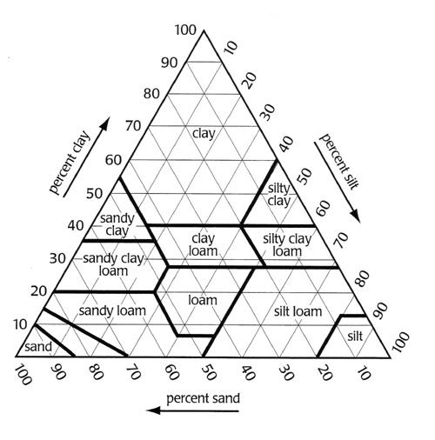

What was the date in which you started germinating your seeds?

What was the date that you planted your seeds in soil?

Look up the best soil texture in which to grow a lemon tree. Write the name of that soil, below:

The first thing we need to know is how much soil you need. Below, design an experiment to determine how much total soil you will need for planting all of your seeds. You will be given four container plots in which to plant all of your seeds.
Before you get started, list the mass of each seed that has germinated in this box. If you have five seeds, you should have five masses. (It might be a good idea to lay your seed(s) on this chart to remember which is which)
M₁= M₂=
M₃= M₄=

Procedure:
- Obtain a try in which to plant your seeds.

Fill in the table for the soil that you created:
Texture | Mass | Percentage
Sand | g | %
Silt (Potting soil) | g | %
Clay (topsoil) | g | %
Total Mass | g | 100%

Knowing what you know about soils, soil’s ability to retain water, and the type of environment in which citrus fruits grow, why do you think this may be a good soil for growing a lemon tree? Explain.

Label the diagram below that mimics the one in which you are planting your seeds to show how many seeds are in each compartment of your tray. (Write the masses of your seeds in the appropriate box)
Does your soil contain an organic layer? Why or why not? Explain.

Now, your assignment after the break will be to design an experiment that will change the rate of growth of your lemon plants. Below, list the variable you wish to change in the experiment, and all of the controls and constants that need to be maintained in order to measure that one variable. Also, what will you be measuring in order to see if growth has occurred or not occurred?
Possible Variables: (list three you might want to try)

Possible Constants: (list some variables that need to stay constant between the
Control group and your Experimental Group)

Possible methods of measuring growth: (give at least two).

