Plate-tectonic theory states that the Earth’s lithosphere is broken into very slowly moving pieces or plates. Plate movements over vast stretches of time have led to the current orientation of our continents and oceans. Individual events along plate boundaries, such as earthquakes and volcanic eruptions, pose periodic threats to human activity and ecosystems. The “Ring of Fire” is a term that describes the location of increased seismic and volcanic activity around the margins of the Pacific Ocean basin. On the map above, each dot represents a volcano or an earthquake.

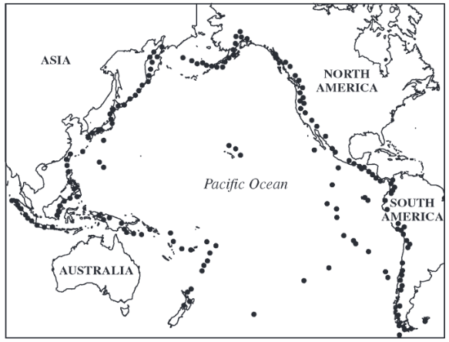
- Japan, Indonesia, and the Philippines are examples of volcanic island chains that have formed along subduction zones between plates in the western Pacific.
  - Describe what happens when two tectonic plates collide along a subduction zone.
  - 1 point for a correct description of plate movement in a subduction zone.
    - One plate is pushed beneath the other, or equivalent description
    - A trench may be formed at the subduction zone
  - Explain how subduction leads to volcanic activity.
  - 2 points: 1 point for a correct explanation of one plate being pushed down and melted and 1 point for a correct explanation of molten material/magma rising to the surface near the zone

- Although the landscape following a volcanic eruption may appear unable to support ecological communities, over time the area can be transformed through succession.
  - What is primary succession?

- 1 point for a correct description of the establishment of organisms where bare rock/ash/sand/inorganic substrate, or no soil previously existed.

  - Explain how primary succession can lead to soil formation on a newly formed volcanic landscape.

- 2 points: 1 point for a correct explanation of the role of organisms in physically/chemically weathering rock and 1 point for a correct explanation of the role of organisms and decomposition in soil formation over time)

- Southern California experiences periodic devastating earthquakes along the San Andreas Fault, which is a transform boundary located along the eastern edge of the Pacific Plate.
  - Describe what happens to the tectonic plates along a transform boundary.
- 1 point for a correct description of the movement of plates when an earthquake occurs.
  - A large amount of energy is released
  - Plates suddenly/rapidly slide past each other in opposite directions
7 total points possible

