- Non-living
- No nucleus
- Genetic material
- Cytoplasm
- Can be both unicellular and multicellular
- Surrounded by a Capsid made of protein
- Simple structure
- Archaebacteria
- Cell membrane
- Membrane-bound organelles
- Animals
- Unicellular ONLY
- Nucleus
- Complex structure
- Protista
- No membrane-bound organelles
- Ribosomes
- Fungi
- Plants
- Eubacteria
- Living
- Attaches to cell by a lock and key fit

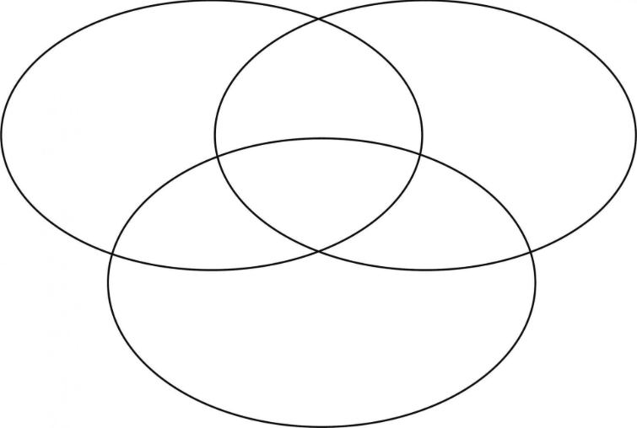

Prokaryote
Eukaryote
Virus

