Website: tigersciencerenteria.com | Email: sarenter@episd.org

Hi guys! I hope everyone is safe and your family is healthy. This is a super weird time for everyone so if you need anything or if there is anything I can do to help you, please let me know. I’m here for you all and I miss seeing you guys.

Remember when several of you said you would never use Biology. Well, now that we’re in a virus pandemic, and you are practicing social distancing to flatten the curve... NOW is when you use biology!
So let’s do some online learning!
- I will be posting weekly assignment on tigersciencerenteria.com starting on Monday and all work is due on Friday. CHECK MY WEBSITE NOT SCHOOLOGY. (Things may be turned in on Schoology but I will post everything you need to know on my website.)
  - If you can’t make the deadline, please message me on Remind or send me an email.

- We are still on A/B schedule. You are still required to “check in” with your classes on designated days.

- Working and learning from home is different and has challenges. Here is a schedule for us to follow:
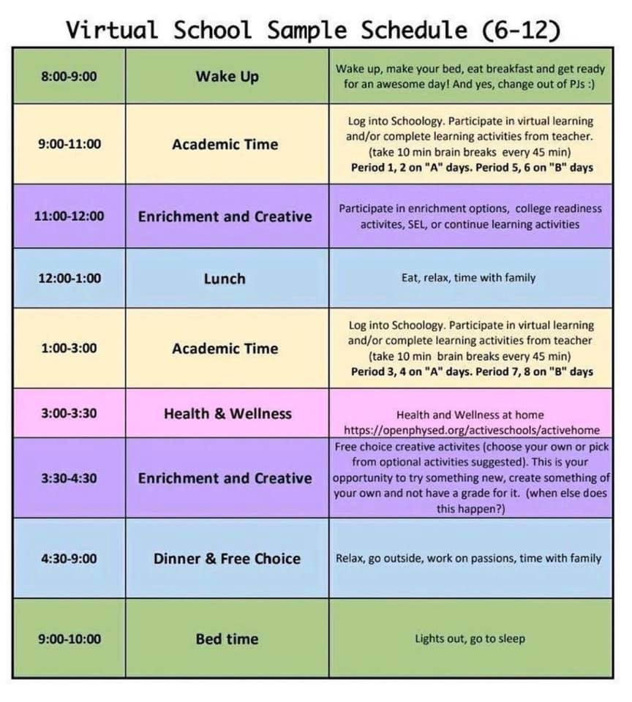

- On Monday and Tuesday, I will be hosting Zoom meetings to discuss the week’s assignment:
  - A Days- Zoom meetings at 9 am (1st and 2nd periods) and again at 1 pm (4th period)
  - B Days- Zoom meeting at 9 am (5th period), 1pm (8th period period) and 2 pm (7th period/APES only)
  - There will be Zoom tutoring hours Monday and Wednesday only from 3pm-4pm
  - * If you can’t make it during your designated time. You can attend any zoom session except 7th period.

ZOOM ETIQUETTE
Meetings will be how we complete class instruction. It is user friendly and you shouldn’t have too much trouble. Here is a link for Getting Started on Zoom.

- Keep your Audio on mute until you want to speak. We must work together to limit background noise.

- Enable Video so that we can see you! I need as much social interaction as I can get from my home office!

- When you want to speak, use the “Raise Hand” feature. On the bottom of the Zoom window, click on “Participants.” Be sure to unmute yourself to talk.

- Use the Chat box to make a point or ask a question. Remember that Chat is public, and may be recorded, and archived.

- Have a plan for taking notes (paper and pencil, digital notepad, Word/Pages doc). We may record and post on Canvas our Zoom class sessions, but you should also try to capture your thoughts and questions in the moment.

- Appropriate classroom behavior is expected in our virtual classroom.

CLASS MOTTO
Mighty Tigers are:
Respectful (language, behaviors)
Open Minded (appreciate diversity, believe the impossible)
Achievers (set goals, challenge yourself)
Responsible (digital citizenship, monitor self)

ACADEMIC INTEGRITY
Science department expectations for academic integrity will follow EPISD policy as stated in EIA Local policy manual.
A student who receives a failing grade (CH) due to academic dishonesty shall not be allowed to redo assignments or retake a test. At the discretion of the teacher, a discipline referral may be issued.
Actions constituting academic dishonesty include, but are not limited to; submitting others work as your own, copying work from another student, plagiarism, cheating, fabrication, inappropriate use of technology, falsifying documents, and allowing others to violate the academic integrity policy. Students have the responsibility to submit coursework that is the result of their own thought, research, or self-expression.

School and district policy is to be followed at all times. This policy can be found in the student handbook and agenda.

